2 Minute Form
Trip Name: Sullivan’s to Motuora Island
Check-in Name and Phone:
Date: Branch:
Leaders
Cell Phone Number
VHF Call Sign &/or Vessel Name
Vehicle make, model, registration, colour
General Plan
Note: If plan changes, you must notify your Check-in person.
Latest Time Off the Water |  |  |  |  | TMP used²⁰
Tide/ Forecast Lake Level | Low |  |  | High | Other
Communications Carried²¹
Communications | We will be communicating as a group on VHF Channel _____
Equipment Carried
Trip Report
(Use other side if more space required)

Activity | Club trip | Centre | Auckland | Location |  |  | Auckland |  | Difficulty¹ |  |  | Intermediate, or strong beginners if conditions are good.
Activity Description | Launch at Sullivan’s Bay and paddle out to Motuora, Island. This is suitable as a day trip, or a multi-day trip, staying at Motuora campsite. Also, consider a side trip to Moturekareka and Motuketekete Islands. |  |  |  | Leader qualification req.² |  | Club Trip Leader
Get in Location | Sullivan’s Bay |  |  |  | Chart/ Map no.⁴ |  | 532 |  | Distance |  |  | 16km total
Get out Location | Sullivan’s Bay |  |  |  | Coastguard Channel |  | 82 & 16 |  | Now-casting |  |  | 21
Emergency get out ⁵ | Saddle Island. |  |  |  | Emergency / Coastguard Station |  | Auckland |  | Phone |  |  | *500  09 303 4303
 |  |  |  |  | Drinking Water⁶ | At Sullivan’s & Motuora |  | Toilets⁷ |  |  | Long drops at Sullivan’s & Motuora
Emergency Response | Refer Emergency Response Booklet |  |  |  |  |  |  | Parking⁸ |  |  | At Sullivan’s Bay
Specific Equipment Required⁹ | Helmets advised if planning on rock gardening. |  |  |  | Working Communications equipment in this area¹⁰ | Cell phone  Sat phone |  |  |  | Mountain Radio |  |  | PLB  VHF
Other resources  and notes¹¹ | Getting there – head north on the motorway, 5km past the tunnel there is a sign to Mahurangi West, turn right and travel for a few km. The road then bends to the left and there is a road which branches off to the right. Take the road to the right and follow it to the beach. This is Sullivan’s Bay aka Otarawao Bay on Google Earth.  Pest free Island – ensure that kayaks and gear are checked for pests – rodents, Argentine ants, Rainbow skinks, seeds. http://motuora.org.nz/ |  |  |  | Weather Parameters¹² | Beginner: no significant surf or swell, wind under 15 knots.  Intermediate: surf or ocean swells less than 1.5 metres or wind under 25 knots.  Advanced: any condition that’s suitable for the trip’s aims.
Previous incidents^{13 unknown}

Safety Management¹⁴
Hazard |  | Significant?  - E/I/M |  | Management Strategy¹⁵ |  |  |  | Hazard | Significant?  - E/I/M | Management Strategy¹⁵
Cold Water |  | Yes - M |  | Carry spare dry clothes and shelter |  |  |  | Deep Water | Yes - E | Correctly fit PFDs
Medical Conditions |  | Yes - M |  | - Leader has first aid qualification  - Ask customers about medical conditions |  |  |  | Bad Weather | Yes - M | Understand weather forecasts.  Have back up plans or pull out if necessary
Capsizing |  | Yes - M |  | - Correctly fit PFDs  - Skills at performing rescues. |  |  |  | Heat / Sun | Yes - M | - Protective Clothing (worn), Sunglasses, Hat  - Sun Screen  - Plenty of drinks
Panic |  | Yes - M |  | Ensure conditions match level  of skills |  |  |  | Obstacles | Yes - M | Awareness of reefs, navigational hazards, nets
Swell |  | Yes – M |  | There is the potential for ocean swell coming on to the islands – ensure that those participating have the skills required for the conditions on the day, particularly if rock gardening, in which case helmets are recommended. |  |  |  | Other Vessels | Yes - M | - Understand the “rules of the sea”  - “Be seen” – Have two of the following; flag, brightly coloured kayak, brightly coloured PFD or hat. At night: an all- round white light & a powerful torch.
Written up by: | Larraine |  | Approved By: |  | Russell Williams | Signed: | RW |  | Date: | 21 July 2014 | Review in: | 12 months from date of approval

Additional Information Sheet (Optional)
Introduction (A general introduction)
Description (A description of the tour – as if you were selling the idea to someone) |  | Motuora is a beautiful island, replanted and stocked with native species. Working bees for planting, weeding etc. are held regularly. Take walking shoes as there are many tracks and excellent views. At the NE corner of the island DOC are encouraging gannets to start a colony. Part of this programme is a speaker system set up on top of the cliff broadcasting gannet calls which can be puzzling if not expected. On the eastern side is Still Bay which is a lovely place for a break. It has golden sand, and pohutakawa trees. Nice rock gardening on the eastern side.  This is a kiwi breeding area, and kiwi are often seen at night, even in the campground.  A side trip to Moturekareka and/or Motuketekete is worthwhile if time permits.
Accommodation/ Campsite Locations |  |  | Facilities
Name | DOC campsite on Motuora |  | Cabins | 1 | Fuel | No
Phone | Phone 027 492 8586 (preferably after 4.30pm) |  | Showers | Cold | Power | No
E-mail | motuorais@xtra.co.nz. |  | Toilets | Long drops | Water Access | Yes
Website | http://www.doc.govt.nz/parks-and-recreation/places-to-stay/conservation-campsites-by-region/auckland/hauraki-gulf-islands-area/motuora-island/ |  | Laundry | No | Pool | No
Physical Address |  |  | Water | Yes | Fires Allowed | no
Other | You also need to pay for overnight parking at Sullivan's Bay. This is $5 per vehicle per night.  The easiest way is to do it by phoning 366 2000 in advance and pay by credit card; or take cash to leave in the box - and you must phone the ranger from the phone provided at the information stand. |  | Supplies | No
Other information

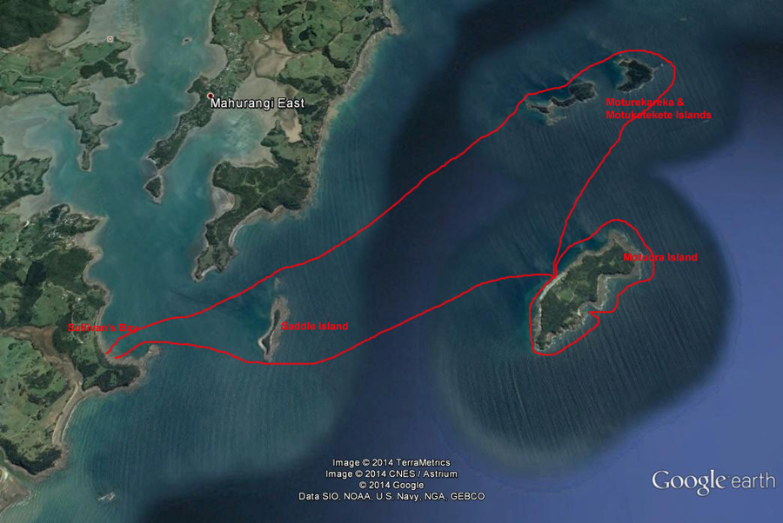
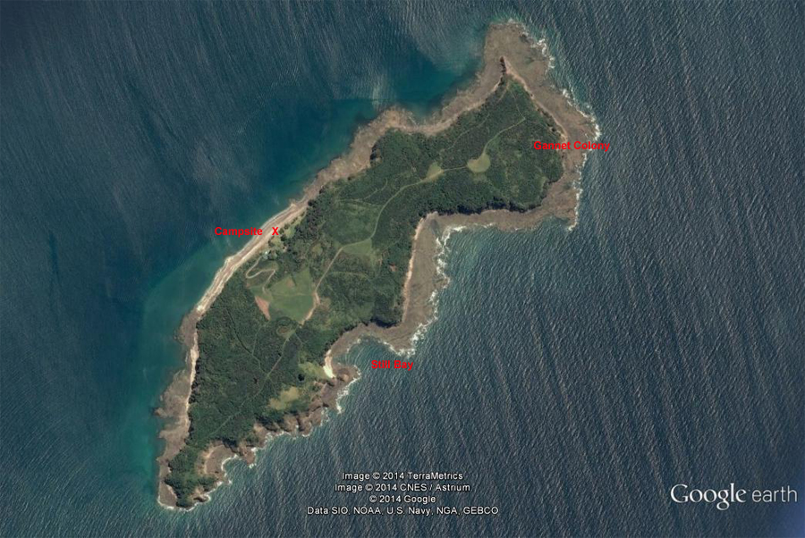

Activity Equipment Check list
Equipment List
- Helmet (rivers & surf) Group Gear
❑ Beanie / hat  Split paddles
❑ Thermals  Repair kit
❑ Paddle Jacket  Fire lighting
❑ PFD  Cooker/thermos
❑ Spray deck  Spare thermals
❑ Booties  Tow system
❑ Water & food  1st Aid Kit
❑ Kayak & paddle  Flares
Group - Oceans & Lakes  Compass
❑ Pumps & Paddle Floats  Charts / Maps
Group - River  GPS (optional)
❑ Throw ropes  Knife (cut rope)
❑ Pin kit & saw  Emergency Shelter

In case of emergency: Dial 111, Mayday :VHF Channel 16

Kayaking Check list

❑ Trip plan
❑ Latest weather forecast
❑ Conditions match skills?
❑ Hyperthermia (hot) &
Hypothermia (cold)
❑ On & off water safety
❑ Environmental concerns
❑ Emergency Procedures include emergency get out.
❑ Working communication devices
e.g. VHF radio, mobile phones, PLB
❑ Specific safety issues for this trip
❑ Participant list
❑ Any medical conditions
❑ All participants keen to proceed?

❑ Trip Plan/ 2-minute form lodged with Ops. Manager

Appropriate wind conditions to run trips:
Novice - no significant surf or swell, wind under 15knots
Intermediate- surf or ocean swells less than 1.5 meter or wind under 25 knots.
Advanced- any condition that is suitable to the trips aims

At conclusion of trip:
Contact check in person
Group Debrief.

Check in Person Ph:
__________________ Mobile
__________________ Work
__________________ Home

Activity Document Cover Sheet

Activity:
Date of Activity:

Activity reports. Is all relevant information present:
– Approved Trip Management Plan (TMP)/ 2 minute form
– Club Trip Participant Sheet
– Weather forecast
– Activity Check List
– Trip report (May be on the 2 minute form)
– Accident / incident reports
Leaders Signature:
Date:

